OC Transpo Route Digitization Project

MacOdrum Library | 8/1/14 | Maps, Data & Government Information Centre

Intro
The OC Transpo Route Digitization Project was started in May 2014 with the goal of digitizing OC Transpo transit routes starting from 2013 and working backwards to 1929. The project was undertaken by Carleton University’s Maps, Data, and Government Information Centre (MADGIC) with funding provided by a Young Canada Works summer internship grant. The digitization and post processing was completed using ArcMap 10.2.

Data
The data used for this project consisted of OC Transpo maps held at the Maps, Data and Government Information Centre, and open datasets made available by online resources.

OC Transpo System Maps
The OC Transpo system maps are smaller-scaled, poster sized maps which display the complete Ottawa transit system. The system maps have been archived within MADGIC’s collection, and consists of both physical maps, as well as scanned digital copies. In general, the September 1st system maps used, except where no September maps were available.
- Ottawa Roadways shapefile
This file was freely download from the Open Data Ottawa catalogue (http://ottawa.ca/en/mobile-apps-and-open-data/open-data-ottawa). It was used to create the majority of the transit routes.

Gatineau Réseau Routier shapefile
Where the transit routes entered Québec, the Réseau Routier shapefile was used. This file was freely downloaded from the Ville de Gatineau open data catalogue (http://www.gatineau.ca/donneesouvertes/donnees_ouvertes_fr.aspx).

Methods
The methodology for creating the final products followed 3 simple steps, as summarized in Figure 1.
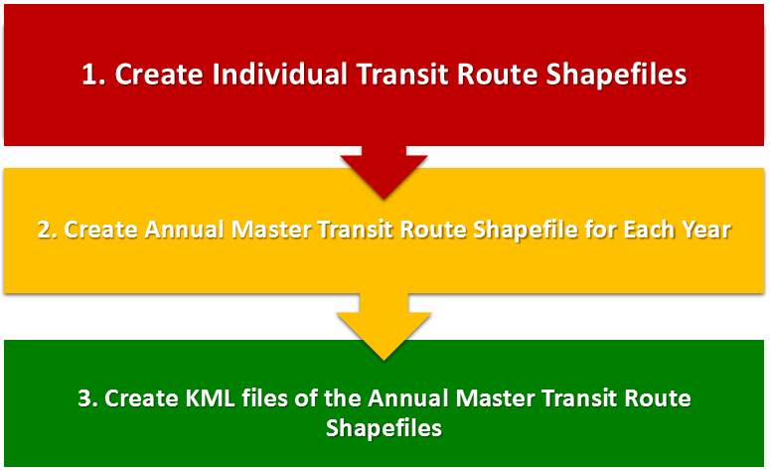
Figure 1: Methodology

Step 1: Creating the Individual Transit Route Shapefiles

The following section outlines the steps taken to create the individual route shapefiles.
i. Select road segments from the road files to create each route

To begin with, each transit route was located on the physical or digital copy of the OC Transpo system map. Then, from the Ottawa and Gatineau road files which had been previously downloaded, the segments of road which made up the transit route were manually selected.
ii. Export selected road segments to a new shapefile for each transit route

Once one entire route had been selected, it was then exported to a new shapefile. Each individual route shapefile was named according to its route number, type and year (e.g. RTE_001_Regular_2013). In the case where one route contained several different types of service, for instance, both regular and limited service, two separate shapefiles were created. Moreover, in some locations, especially along the Transitway, road segments were absent from the Ottawa and Gatineau road files. In these cases, the missing segments were manually digitized, sometimes using the help of aerial imagery.

iii. Add attribute data to individual transit route shapefiles

Attribute data was added to each newly created route shapefile. The fields are summarized in Table 1, and a sample of an attribute table is shown in Figure 2. As can be seen in Figure 2, so far, each route’s shapefile consisted of many road segments (e.g. 169).
The above steps were repeated for each year; however, the process was greatly accelerated by using the routes of more recent years as templates for previous years, and making edits where necessary.
Table 1: Route Attribute Data
Attribute Label | Description | Attribute Categories
RTE_NUM | The transit route number as labeled by the OC Transpo System maps | 001, 087, 146, etc.
RTE_TYPE | The route service type, as represented by the system map legend | Regular Route  Peak Route  Limited Service  Express Route  Rural Express Route  Rural Shopping Route  Otrain
MODE | The mode of transportation | Bus  Train
YEAR | The year of each route’s existence

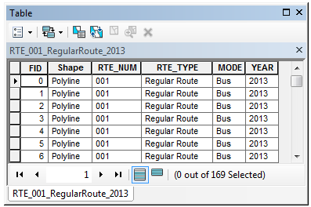
Figure 2: Sample Route Attribute Data

Step 2: Creating the Individual Transit Route Shapefiles

Once the individual routes had been created for each year, a master transit route shapefile was created. Theses master transit route shapefiles contain all routes per year, with each unique route number-type combination being represented by a single polyline segment. The section below details the process used to create these shapefiles.
i. Merge all individual transit route shapefiles for one year into a single shapefile

For a given year, there were approximately 150 or so separate route shapefiles; all of these individual transit route shapefiles were combined into a single shapefile for each year. This was completed using the Merge Tool found in the Data Management toolbox.
ii. Dissolve by the RTE_NUM and RTE_TYPE fields

These new shapefiles were then further processed using the Dissolve tool. By dissolving by the RTE_NUM and RTE_TYPE fields, each unique route, which had previously consisted of many road segments, now melded together to become single polylines.

Step 3: Creating the .kml Files

Finally, the master transit route shapefiles were converted into .kml files for use in Google Earth. Having the files in .kml format will enable non-GIS users to more easily make use of data without learning GIS specific software.

i. Add temporary NUM_TYPE field to the master transit route shapefiles

Prior to exporting the master transit route shapefiles to .kml files, a temporary “NUM_TYPE” field was added to each shapefile which contained both the route number and the route type information (e.g. 001 Regular Route).

ii. Symbolize the shapefiles by the NUM_TYPE field and colour code according to transit route type

The shapefile’s symbology was then set to display the NUM_TYPE field, and the colours were manually set according to the route service types (see Table 2). This symbology would be automatically applied to the resulting .kml following the export process.
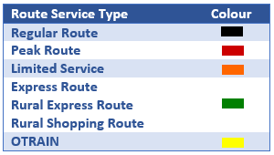
Table 2: Route Type Legend

iii. Export to .kml

Using the Export to KML 2.5 tool (downloaded from http://arcscripts.esri.com/details.asp?dbid=14273), each year’s master transit route shapefile was exported to .kml.

The final .kml files were symbolized exactly as the shapefiles so that they displayed all unique route number-type combinations as legend items, and were colour coded by route service type. Once the export to .kml was completed, the temporary NUM_TYPE field was deleted from the shapefiles.

Conclusion
Within the time frame of May to September 2014, sixteen complete years were digitized, from 2013 through to 1996. The project will have to be continued by subsequent technicians in order to complete the remaining years, as well as to keep up with future years.
The final products included the individual route shapefiles, the annual master transit route shapefiles and their accompanying .kml files for each of the 16 completed years. These files can be freely distributed for public use, and as such, will be available online from the MacOdrum Library website and be shared with OC Transpo.

